|  |
| --- |
| KOJIMA PRODUCTIONS |
| Metal Jump X |
| An action platformer game |
| Version 1.0  All work Copyright © 2021 by Kojima Productions.  All rights reserved. |
| **Trung Le - 101264698** |
|  |



|  |
| --- |
| November 21st 2021 |

**Table of Contents**

Contents

1. Detailed Game Description 4

2. Controls 4

3. Interface Sketches 5

4. Screen Descriptions 7

5. Game World 9

6. Levels 9

7. Characters 10

8. Enemies 10

9. Weapons 11

10. Scoring 11

11. Sound Index 11

12. Art / Multimedia Index 11

**Version History**

* 1.0 – Initial proposal

# Detailed Game Description

* Metal Jump X is an action platformer mobile game inspired by the Metal Slug series.
* Player controls a high tech mech suit to go through the jungle & fight robots + monsters.
* The player will move via an on-screen joystick, with 1 button to shoot & 1 to jump.
* Player will need to run, jump, and navigate to avoid bullets & traps, while aiming to defeat enemies for scores & gain powerups/healing items.
* GitHub: <https://github.com/KojimaMcMaple/GAME-2014_A2>

# Controls

* The player will move via an on-screen joystick, with 1 button to shoot & 1 to jump.

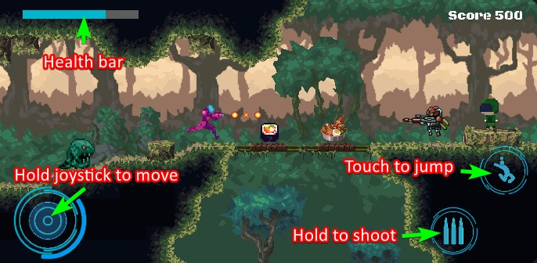

# Interface Sketches

* Created in Unity with appropriate settings.
* Menu Screen:

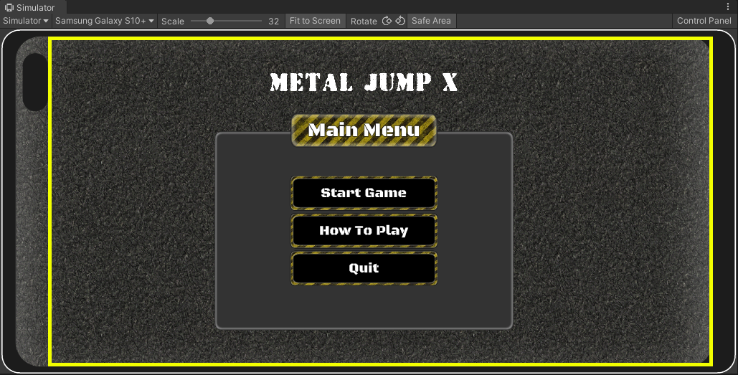

* Instructions Screen:

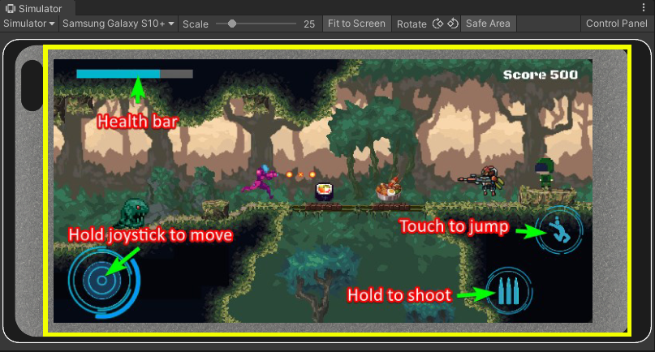

* Gameplay Screen:

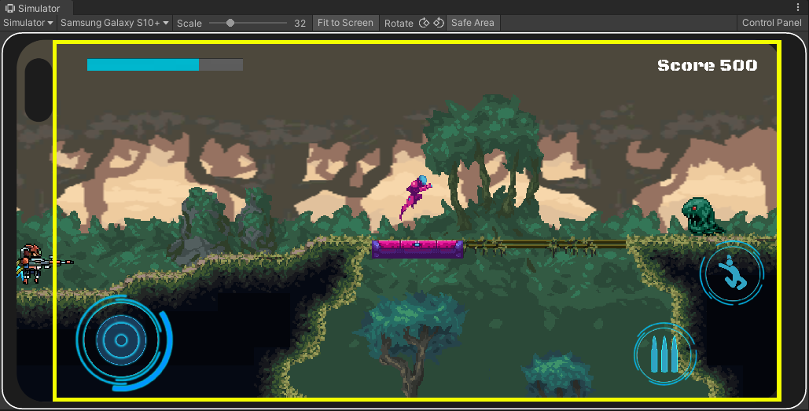

* Game Over Screen:

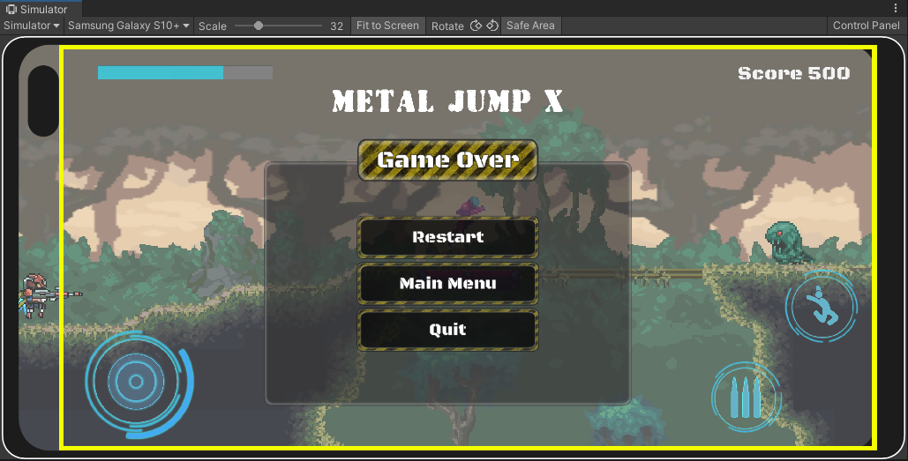

# Screen Descriptions

* Menu Screen:
  + Start Game: Launch the game
  + How To Play: Open control scheme
  + Quit: Exit application



* Instructions Screen:
  + Details on how to control the character and UI elements



* Gameplay Screen:
  + Top left: Health bar
  + Top right: Game score
  + Bottom left: On-screen joystick
  + Bottom-right: Jump & shoot buttons



* Game Over Screen:
  + Restart: Restart the game level
  + How To Play: Open control scheme
  + Quit: Exit application



# Game World

* The game is set in a fictional modern world, with both advanced futuristic technology and conventional firearms, as well as monsters for variety.
* The game is set in the jungle environment, with integrated caverns here and there.
* There will be traps scattered around to challenge the player’s platformer skill.

# Levels

* Level 1: Jungle level with light platforming to teach player how to move

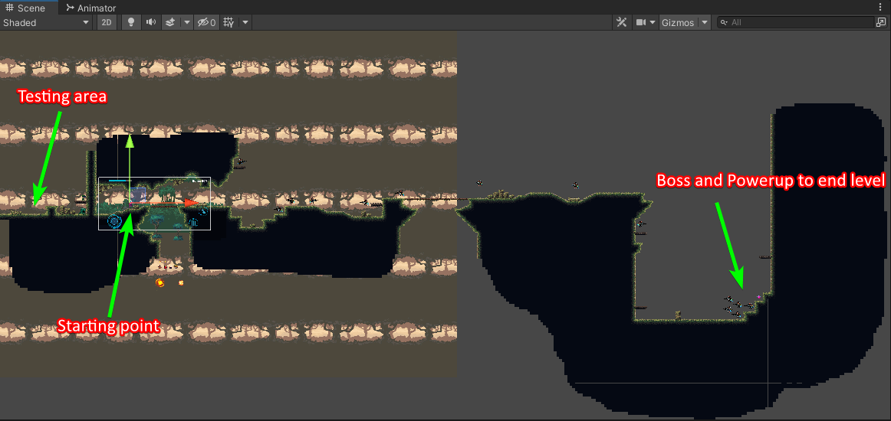

* Level 2 [TBD]: Cavern level with traps to challenge player, as well as a boss at the end of the level.
* Level 3+ [TBD]: To be decided for future release…

# Characters

* The protagonist is codenamed SNAKE. He wears an advanced tactical suit with energy weapon and can synergize environmental tech to power itself up.

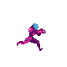

# Enemies

* Robot: aggressive, use ranged weapon, hard to take down
  + Idle when nothing in field of view
  + Attacks when player stays in field of view
* Soldier: has strength in number, use ranged weapon, easy target
* Slime: chase player, use close-range attacks

# Platforms

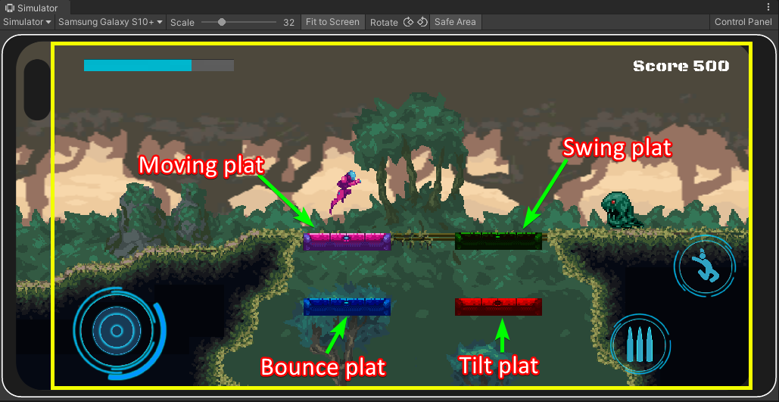

# Weapons

* Default cannon: shoots individual bullets
* Rapid cannon: obtained via powerups, rapid fire energy beams until player gets hit

# Scoring

* Player can score by defeating enemies and eating health items while at full health.
* Food behaviors:
  + 4 tier: low (5 pts), default (10 pts), high (20 pts), beyond (30 pts)
  + Restores HP if <100%, increases score if HP = 100%

# Sound Index

* menu.wav: menu soundtrack
* battle.wav: battle soundtrack
* enemy_hit.ogg: enemy hit SFX
* menu_click.wav: menu click SFX
* normal_shot.ogg: player default shoot SFX
* player_explosion01.wav: player death SFX
* powerup.wav: player powerup SFX
* rapid_shot.ogg: player powered up shoot SFX
* robot_explode01.flac: enemy robot death SFX
* robot_explode02.wav: enemy robot death SFX
* robot_shoot.mp3: enemy robot shoot SFX
* soldier_shoot.ogg: soldier shoot SFX

# Art / Multimedia Index

* "W:\WD_DATA\GBC\S5\GAME 2014_MOBILE GAME DEVELOPMENT I\ASSIGN\GAME-2014_A2\GAME-2014_A2\Assets\Warped Caves\Artwork\Sprites\player": player sprites



* "W:\WD_DATA\GBC\S5\GAME 2014_MOBILE GAME DEVELOPMENT I\ASSIGN\GAME-2014_A2\GAME-2014_A2\Assets\DualCorStudios\BasicUI Caution\Prefabs": menu UI objects

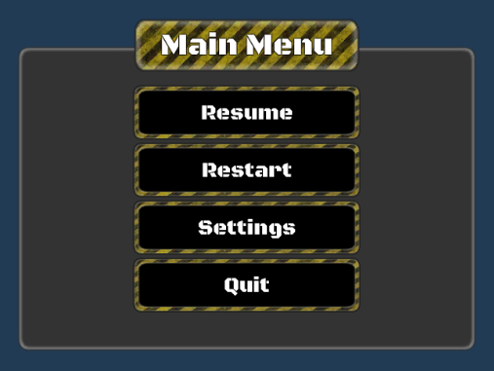

* "W:\WD_DATA\GBC\S5\GAME 2014_MOBILE GAME DEVELOPMENT I\ASSIGN\GAME-2014_A2\GAME-2014_A2\Assets\Robot Shooting Game\Robot": robot enemy sprites

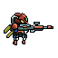

* "W:\WD_DATA\GBC\S5\GAME 2014_MOBILE GAME DEVELOPMENT I\ASSIGN\GAME-2014_A2\GAME-2014_A2\Assets\Free Pixel Army\Prefabs": soldier enemy sprites

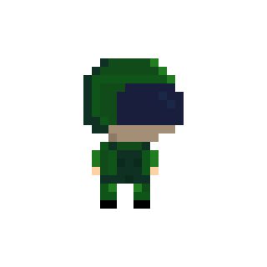

* "W:\WD_DATA\GBC\S5\GAME 2014_MOBILE GAME DEVELOPMENT I\ASSIGN\GAME-2014_A2\GAME-2014_A2\Assets\Slime\Prefab": slime enemy sprites



* "W:\WD_DATA\GBC\S5\GAME 2014_MOBILE GAME DEVELOPMENT I\ASSIGN\GAME-2014_A2\GAME-2014_A2\Assets\FreePixelFood\Sprite\Food": food pickup objects



* "W:\WD_DATA\GBC\S5\GAME 2014_MOBILE GAME DEVELOPMENT I\ASSIGN\GAME-2014_A2\GAME-2014_A2\Assets\MainAsset\png\64": food pickup objects with more details



* "W:\WD_DATA\GBC\S5\GAME 2014_MOBILE GAME DEVELOPMENT I\ASSIGN\GAME-2014_A2\GAME-2014_A2\Assets\Sprites": bullet objects

